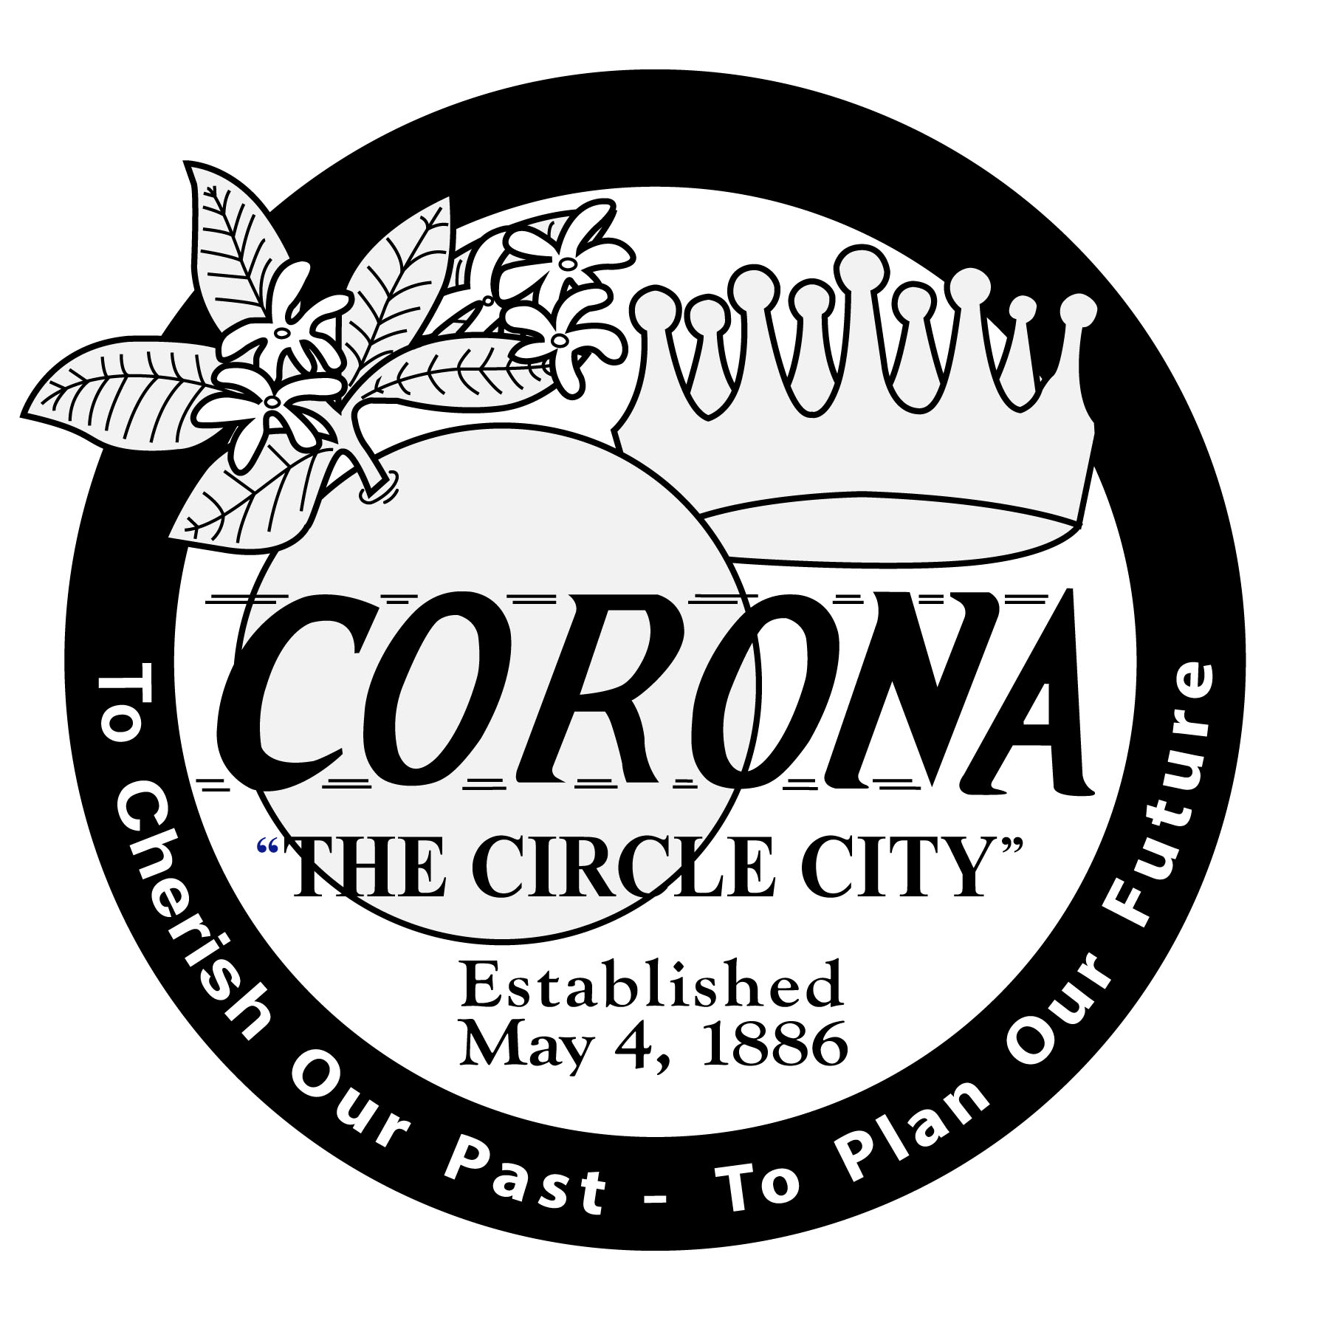

CITY OF CORONA
OFFICE OF THE CITY CLERK

PUBLIC NOTICE IS HEREBY GIVEN that the City Council of the City of Corona, California, will conduct a public meeting in the Council Chamber, at Corona City Hall, 400 S. Vicentia Avenue, in said City of Corona, Wednesday, April 1, 2020 at 6:30 p.m., to consider the following:

NOTICE OF INTENT TO ADOPT A MITIGATED NEGATIVE DECLARATION FOR
THE LATITUDE BUSINESS PARK

The Latitude Business Park is a planned industrial and warehouse development on 75 acres located at the northwest corner of Tom Barnes Road and Temescal Canyon Road in the City of Corona. The project site is within the El Cerrito Specific Plan and zoned Light Industry. The applications being considered for the project include:

Parcel Map 37608 (PM 37608), the subdivision of 75 acres into 13 lots; and Precise Plan 2019-0001 (PP2019-0001), the review of the site design for 15 industrial and warehouse buildings ranging from 18,234 square feet to 253,799 square feet for a total combined building square footage of 1,074,771 square feet on 75 acres located at the northwest corner of Tom Barnes Road and Temescal Canyon Road in the Light Industry (LI) zone of the El Cerrito Specific Plan.

Pursuant to State CEQA Guidelines §15063, an Initial Study was prepared for the project to determine if the project may have a significant effect on the environment. The City as the lead agency determined that the project may have potentially significant effects, but these significant effects are capable of being mitigated to a point where clearly no significant effects would occur; and there is no substantial evidence, in light of the whole record before the city, that the project may have a significant effect on the environment. Therefore, per CEQA §15070(b), the city has prepared a Mitigated Negative Declaration for the project. The Mitigated Negative Declaration and Mitigation Monitoring Report for the project is being recommended for adoption by the City Council at its public meeting on April 1, 2020. The Initial Study/Mitigated Negative Declaration was submitted to the State Clearinghouse (SCH # 2020019017) on January 7, 2020 and made available for public comment for a period of 30 days. The public comment period closed on February 8, 2020. Copies of the Draft Mitigated Negative Declaration was made available on the city’s website at https://www.coronaca.gov/government/departments-divisions/building/projects and at Corona City Hall in the Community Development Department. The Final Mitigated Negative Declaration being considered by the City Council on April 1, 2020, is also available for review at the above website address.

The public is invited to review the Final Mitigated Negative Declaration for the project. Written comments can be submitted to the City Clerk for inclusion into the public record. If you challenge any portion of this project in court, you may be limited to raising only those issues you or someone else raised at the public meeting described in this notice, or in written correspondence delivered at, or prior to the public meeting. Any person unable to attend the public meeting may submit written comments to the City Clerk, 400 S. Vicentia Avenue, Corona, CA 92882. If you have questions regarding this notice or the application to be heard, please call the Community Development Department at (951) 736-2434 or email Joanne Coletta at Joanne.Coletta@CoronaCA.gov

Sylvia Edwards, City Clerk
Published:

