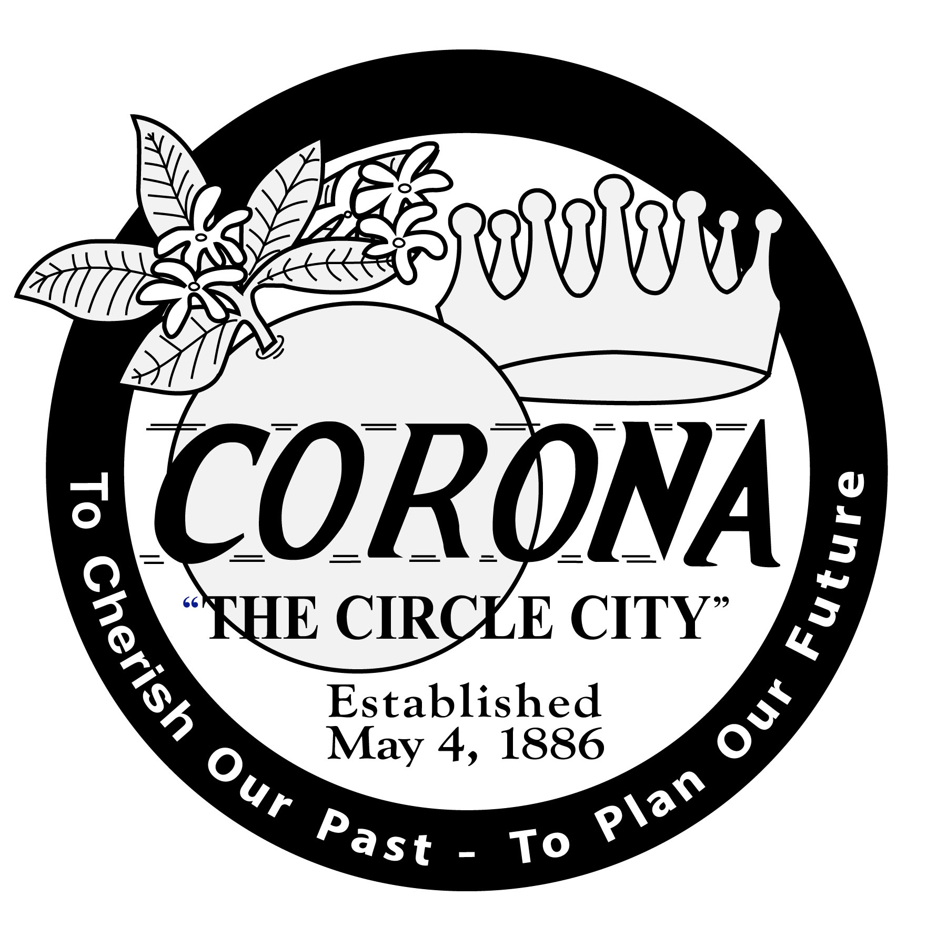
PUBLIC NOTICE
REGARDING PROPOSED ORDINANCES NO. 3372 & 3374
URGENCY ORDINANCES NO. 3371 & 3373

NOTICE IS HEREBY GIVEN that on June 7, 2023, the Corona City Council introduced the following Ordinance(s):

Ordinance No. 3371 Urgency Ordinance No. 3371 amend Sections 17.33.030 and 17.35.020 of Title 17 (Zoning) of the Corona Municipal Code to allow residential land uses in commercial zones pursuant to Senate Bill 6 and Assembly Bill 2011.

Ordinance No. 3372 First reading of an ordinance of the City of Corona, California, amending Sections 17.33.030 and 17.35.020 of Title 17 (Zoning) of the Corona Municipal Code to allow residential land uses in commercial zones pursuant to Senate Bill 6 and Assembly Bill 2011.

Ordinance No. 3373 Urgency Ordinance No. 3373 approving amendments to various specific plans to allow residential land uses in commercial and business park zoning designations pursuant to Senate Bill 6 and Assembly Bill 2011.

Ordinance No. 3374 First reading of an ordinance of the City of Corona, California, approving amendments to various specific plans to allow residential land uses in commercial and business park zoning designations pursuant to Senate Bill 6 and Assembly Bill 2011.

A certified copy of the full text of this ordinance(s) is available for review in the Office of the City Clerk, City of Corona, 400 S. Vicentia Avenue, Suite 115, Corona, CA 92882

The City Council meets the first and third Wednesday of the month at 6:30 p.m. in the Council Chambers located at City Hall.

Sylvia Edwards, City Clerk

Published: June 16, 2023

