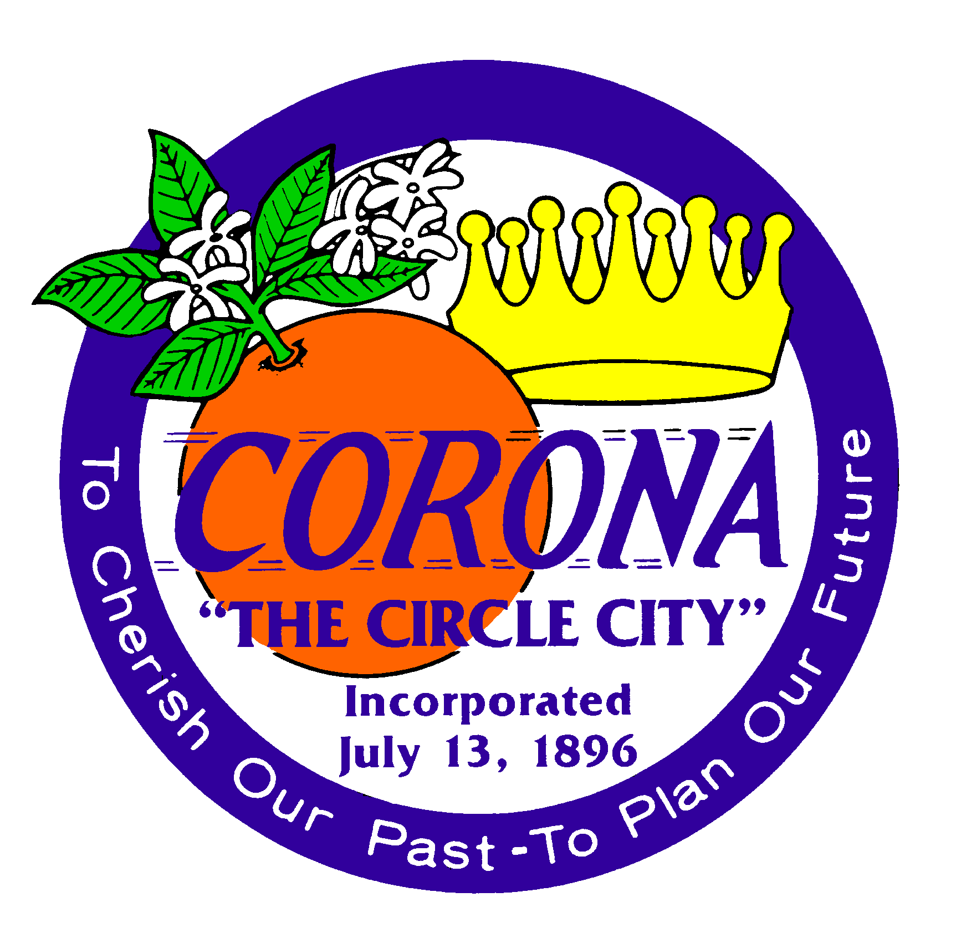

APPEAL TO
ADMINISTRATIVE CITATION

If you wish to appeal the Administrative Citation, please send this form to City of Corona, C/O Citation Processing Center, P.O. Box 7275, Newport Beach, CA 92658. A credit card payment may be made on-line at www.citationinfo.com or call (800) 861-7422. This must be accomplished no later than 15 calendar days from the date the Administrative Citation was issued. You must pay, as a deposit, the full amount of the citation, at the time you file the appeal.

Amount of Appeal: $_____________

CITATION ISSUED TO:

Name:

Mailing Address:

Daytime Phone:

CITATION ISSUED BY:

Dated:

Citation Number:

Property location:

Section 1.08.160 (A) of the Corona Municipal Code states that the request for appeal shall consist of a detailed written explanation as to why the specific sections on the citation are being contested. In the area provided below, give a detailed account of why you are contesting this citation. Please note that without being specific as to why you contest the charges, your appeal will be sent back to you to re-write and return by the codified time frame of fifteen (15) days from date of issuance. You may attach extra sheets of paper as needed.

________________________________________________________________________________________________________________________________________________________________________________________________________________________________________________________________________________________________________________________________________________________________________________________________________________________________________________________________________________________________________________________________________________________________________________________________________________________________________________________________________
_________________________________________________________________________________

Appealed by: _________________________ __________________________
(Signature) (Date)

